[*INFORMATION][*CUSTOMERDETAILS][*PAGEBREAK]
[/*PAGEBREAK]
PO Box 963
Warrington
WA4 9BZ

[@CURRENTADDRESSTITLE]
[@CURRENTADDRESS]

[@CURRENTDATE]

Important: Confirmation of the set-up of your Direct Debit Instruction including future
payment schedule

Dear [@COAPPLICANT]

Mortgage Application Reference: [@APPLICATIONNUMBER]

Thank you for telephoning us to advise of your Direct Debit details, in turn we have recorded the following:

- Account name: [@ACCOUNTNAME]
- Account number: [@ACCOUNTNUMBER]
- Frequency of collection: Monthly
- Sort Code: [@SORTCODE]
- Amount to be debited: £[@DEBITAMOUNT]

If any of the above details are incorrect, please call us as soon as possible on 0845 052 2280. However, if your details are correct, then no further action is required on your part, and your Direct Debit will be processed as normal. You have the right to cancel your Direct Debit at any time and a copy of the Direct Debit Guarantee is detailed below.

For your information, the collections will be made using this reference number:

- Originator Identification Number: 422508
- Reference: DB UK Bank Ltd
Should you have any queries regarding the above please do not hesitate to contact us on 0845 052 2280 between the hours of 9.00am and 5.00pm Monday to Friday.

Yours sincerely

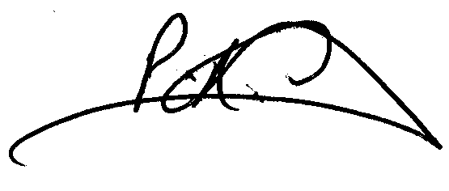

Paul Graham
Director of Operations
db mortgages

YOUR HOME MAY BE AT RISK IF YOU DO NOT KEEP UP REPAYMENTS ON YOUR MORTGAGE

The Direct Debit Guarantee

- This Guarantee is offered by all Banks and Building Societies that take part in the Direct Debit Scheme.
The efficiency and security of the Scheme is monitored and protected by your own Bank or Building Society.

- If the amounts to be paid or the payment dates change DB UK Bank Limited will notify you 10 working days in advance of your account being debited or as otherwise agreed.

- If an error is made by DB UK Bank Limited or your Bank or Building Society, you are guaranteed a full and immediate refund from your branch of the amount paid.

- You can cancel a Direct Debit at any time by writing to your Bank or Building Society. Please also send a copy of your letter to us.

[/*CUSTOMERDETAILS][/*INFORMATION]

